|  |
| --- |
|  |
| Manual Load Planning & Manifesting |
|  |
| |  |  | | --- | --- | | Project Code | 28383 | | Project Name | WMS Support Phase I & II | |
| |  |  |  | | --- | --- | --- | | Prepared/Modified by | Role | Date of Preparation | | HussainBasha Pathan | Team Member | 03/09/2016 | | Reviewed by | Role | Date of Review | | Sabita Prasad | Project Lead | 03/11/2016 | | Approved by | Role | Date of Approval | | Sabita Prasad | Project Lead | 03/11/2016 | | Circulation List | WMS Team |  | | Version Number | 1.0 |  | |
|  |

|  |
| --- |
|  |

**Issue Description:** User will receive error while Manifesting cartons like “Failed to assign oLPN to Shipment” or “Cannot edit destination address as part of Order/Shipment is manifested User will receive error while Manifesting cartons like “Failed to assign oLPN to Shipment” or “Cannot edit destination address as part of Order/Shipment is manifested”.

***Re*** ***Manual Load Planning and Manifesting.***

**Severity:** Medium

**Description:** User will get error while manifesting cartons like “Failed to assign oLPN to Shipment” or “Cannot edit destination address as part of Order/Shipment is manifested”. In these cases we need to do **manual load planning** for the given cartons and then manifest the cartons one by one. Sample copy of the email is attached below.

 

**Step 1: Do the below checks on the oLPN**

* Check the carton status. Should be Weighed (30).
* Take tc_order_id from oLPN
* Tracking number will be updated
* Take tc_shipment_id
* Take ship_via

1. **Login to the DB and take the tc_order_id from the lpn table using the below query**

Select * from dm.lpn where tc_lpn_id = '00000197181416618289';

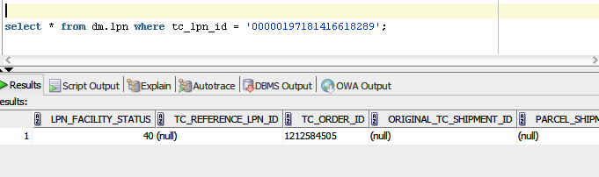

1. **Check the shipment status on shipment table using the below query**

Select * from DM.SHIPMENT where TC_SHIPMENT_ID='CS12954040';

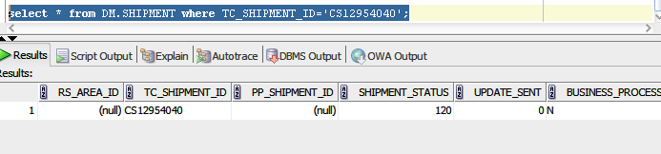

1. **Check the ship_via description for oLPN.**

Select * from dm.SHIP_VIA where ship_via = 'UPSC';

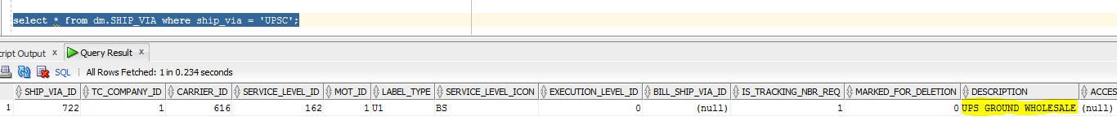

1. **Need to do Manual load planning and manifest oLPNs one by one.**
2. **Go to ‘Manual Load Planning’ option in UI. Take the shipment id you collected in step 1 and apply as shown below.**

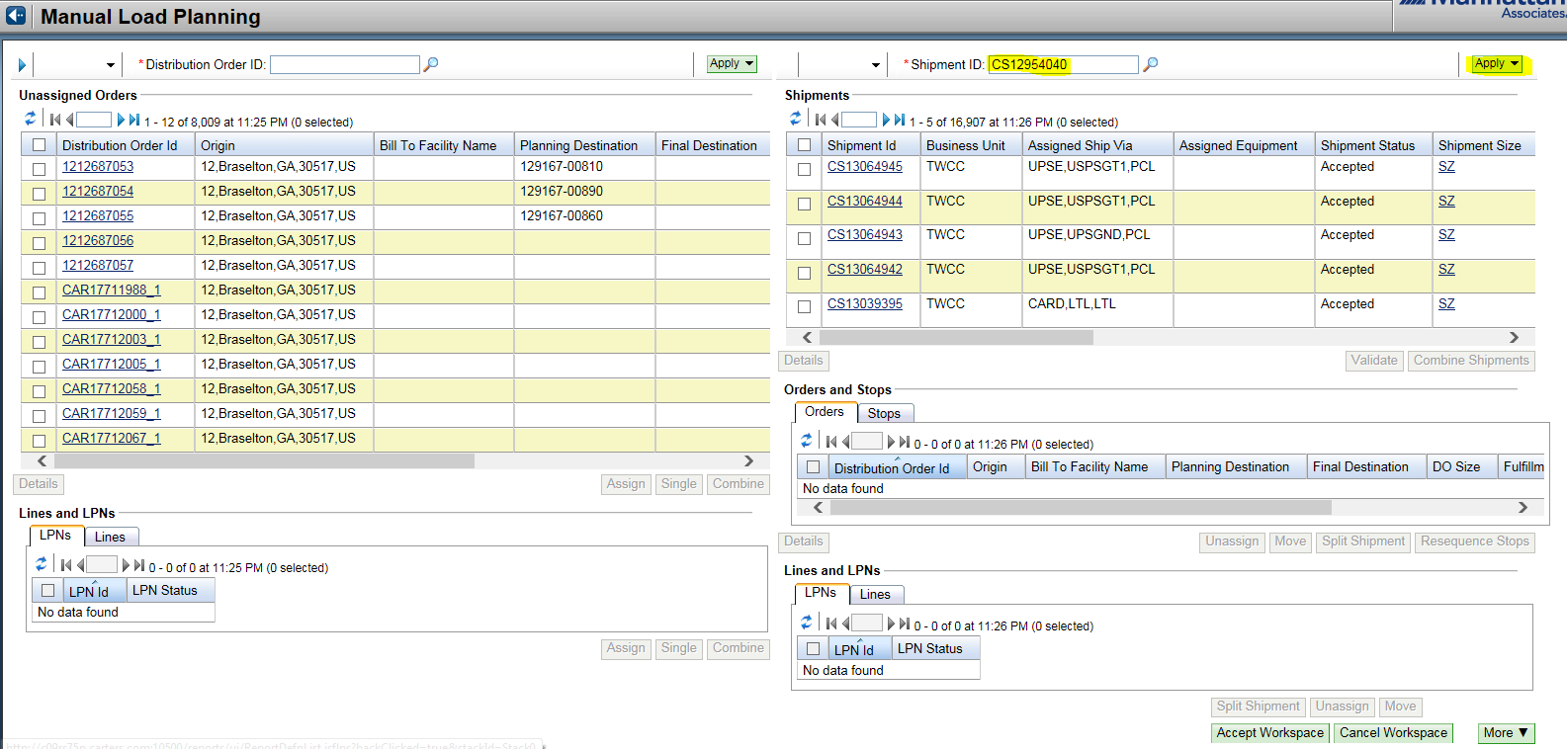

1. **Now select shipment and click on Details as shown below**

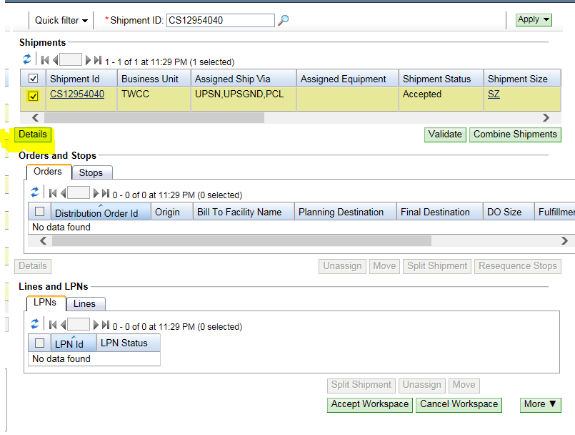

1. **Select Order and Unassign as shown below. Then click on Accept Workspace.**

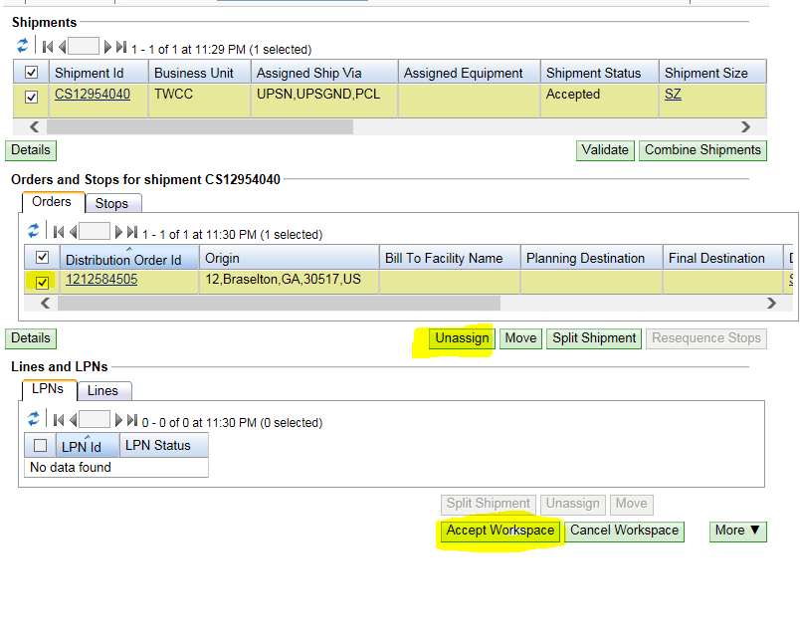

1. **Take the order id collected from step 1 from left window. Select it and click Single.**

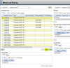

1. **Then Accept Workspace**

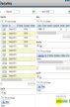

1. **You can see a new Shipment ID is assigned to oLPN.**
2. **Now go to Weigh and Manifest oLPNs option in UI. Give carton number and click Next as shown in the below image.**

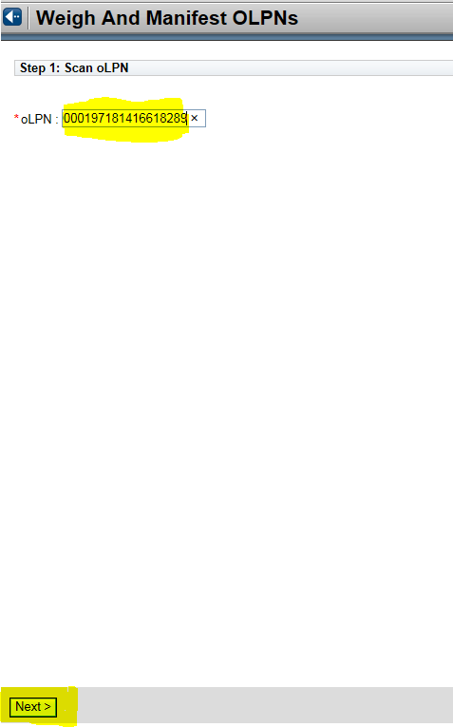

1. **Change the ship_via to the ship via description you collected from the above step 3. In this case it is UPS GROUND WHOLESALE. Click on Manifest.**

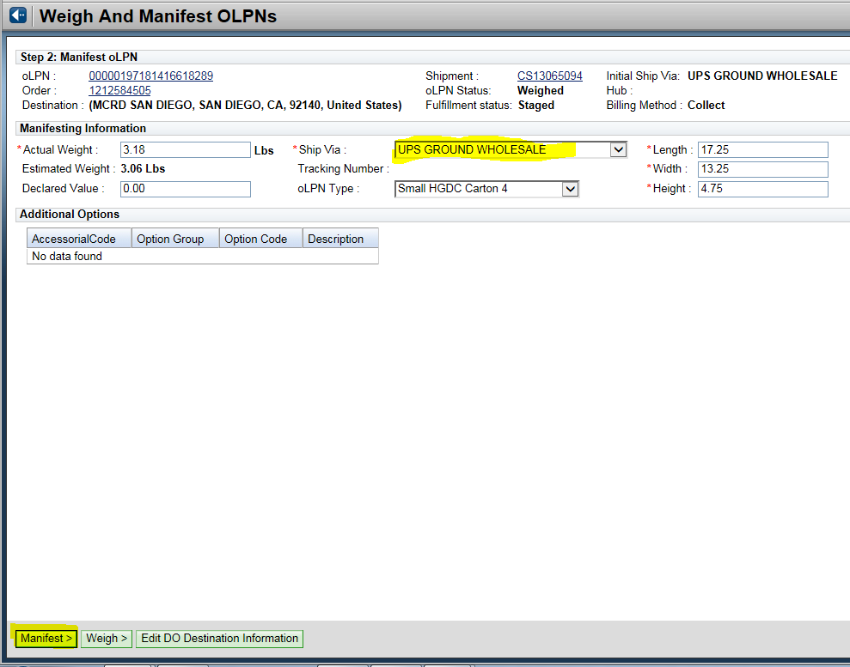

1. **Check the carton and fulfillment status as Manifested and click on Exit.**

